**Illuminate Your Space with Stylish LED Mirrors**

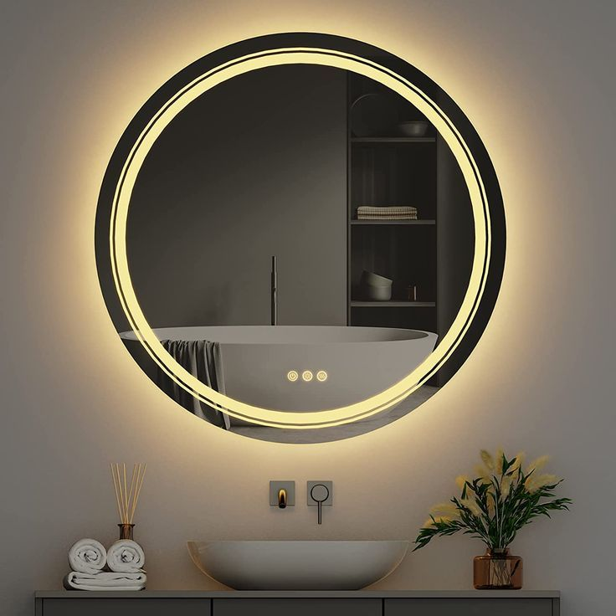

LED Mirrors bring a perfect blend of modernity and functionality to your home. Equipped with energy-efficient lighting, these mirrors not only provide clear, crisp reflections but also brighten up your space with a soft, ambient glow.

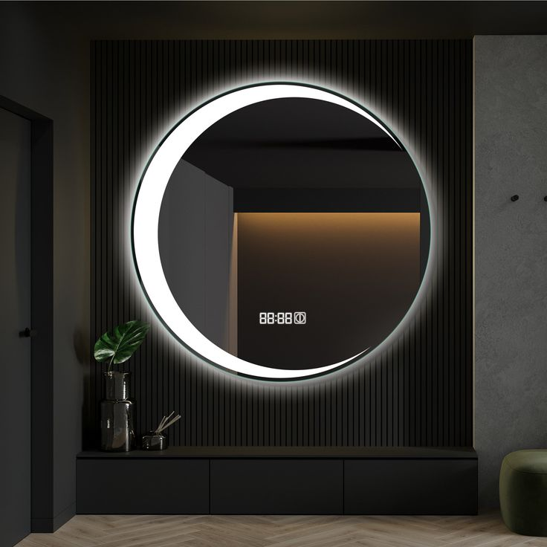Ideal for bathrooms, dressing rooms, or even entryways, LED mirrors are designed to offer both practicality and a touch of luxury. Whether it’s for your daily grooming routine or simply enhancing the atmosphere, the built-in LED lights ensure optimal visibility while creating a soothing, sophisticated effect.

These mirrors are available in various shapes and sizes, featuring adjustable light settings to suit your mood or lighting needs. With a sleek, contemporary design, they become the centerpiece of any room, adding elegance while illuminating your surroundings.

Let your reflection shine brighter with a LED mirror — where style meets function in a single, illuminated frame.